A FIELD PROJECT REPORT ON

**ONLINE EVENT MANAGEMENT SYSTEM**

Submitted in partial fulfilment of the requirements for the award of the degree

**BACHELOR OF TECHNOLOGY**

in

**COMPUTER SCIENCE ENGINEERING**

Submitted by

|  |  |
| --- | --- |
| Lokya Lochana | 231FA04F97 |
| Thanuj krishna | 231FA04E50 |
| Sai Krishna | 231FA04E68 |
| Chaganti Dinesh | 231FA04E96 |
| Hemanth | 231FA04E91 |



Department of CSE

Vignan’s Foundation for Science, Technology and Research (Deemed to be University) Vadlamudi, Guntur, Andhra Pradesh-522213, India

**March – 2025**



**CERTIFICATE**

This is to certify that the field project entitled “ONLINE EVENT MANAGEMENT SYSTEM” being submitted by Thanuj Krishna (Registration Number: 231FA04E50), Sai Krishna (Registration Number: 231FA04E68), Hemanth (Registration Number: 231FA04E91), Dinesh (Registration Number: 231FA04E96), and Lokya Lochana (Registration Number: 231FA04F97) in partial fulfilment of Bachelor of Technology in the Department of CSE, Vignan’s Foundation For Science Technology & Research (Deemed to be University), Vadlamudi, Guntur District, Andhra Pradesh, India, is a bonafide work carried out by them under my guidance and supervision.

|  |  |
| --- | --- |
| **Head of the Department** | **Guide** |

**DECLARATION**

We hereby declare that our project work described in the field project titled “ONLINE EVENT MANAGEMENT SYSTEM” which is being submitted by us for the partial fulfilment in the department of CSE, Vignan’s Foundation for Science, Technology and Research (Deemed to be University), Vadlamudi, Guntur, Andhra Pradesh, and the result of investigations are carried out by us under the guidance of Mrs Ch. Swarna Lalitha.

|  |  |  |
| --- | --- | --- |
| Lokya Lochana | 231FA04F97 | __________ |
| Thanuj Krishna | 231FA04E50 | __________ |
| Sai Krishna | 231FA04E68 | __________ |
| Dinesh | 231FA04E96 | __________ |
| Hemanth | 231FA04E91 | __________ |

**Contents**

| **Chapter No.** | **Description** | **Page No.** |
| --- | --- | --- |
| 1 | Introduction | 5 |
| 2 | Problem Definition | 5 |
| 4 | Proposed System | 6 |
| 6 | abstract | 7 |
| 9 | System Design | 9 |
| 10 | Conclusion | 9 |
| 11 | References | 9 |

**IDENTIFICATION OF PROJECT DOMAIN**

Event management is a rapidly growing industry, encompassing corporate meetings, social gatherings, weddings, conferences, and entertainment events.

The increasing demand for seamless event execution has led to the rise of online event management systems, which integrate various functionalities into a single platform.

The primary users of this system include:

* **Event Organizers**: Manage events, book vendors, and oversee execution.
* **Vendors**: Provide services such as catering, decorations, entertainment, and photography.
* **Attendees**: Register for events, receive updates, and provide feedback.

This project aims to develop a user-friendly, scalable, and feature-rich online event management platform that caters to various event types, ensuring a hassle-free experience for organizers and attendees.

### ****PROBLEM DEFINITION****

The problem identified is the lack of an integrated, automated event management system that provides complete control over event planning while reducing manual workload.

**Proposed Solution**:  
The Online Event Management System aims to:

* Streamline event planning by providing a centralized platform.
* Automate venue booking and vendor selection based on availability, budget, and preferences.
* Enable online guest invitations and RSVP tracking for seamless guest management.
* Facilitate real-time collaboration between organizers, vendors, and attendees.

### ****System Modules****

1. **User Management**: Registration, login, and role-based access control.
2. **Event Planning Dashboard**: Tools for scheduling, budgeting, and assigning tasks.
3. **Vendor Management**: Service listings, availability tracking, and booking confirmation.
4. **Guest Management**: Invitation automation, RSVP tracking, and guest check-in.

**Proposed Solution**:  
The Online Event Management System aims to:

* Streamline event planning by providing a centralized platform.
* Automate venue booking and vendor selection based on availability, budget, and preferences.
* Enable online guest invitations and RSVP tracking for seamless guest management.

### ****SUBMISSION OF ABSTRACT****

The abstract of this project provides a concise summary of the Online Event Management System, including its purpose, scope, objectives, and expected outcomes.

**Abstract Content**:

* **Title**: Online Event Management System
* **Domain**: Web-Based Event Planning and Automation
* **Purpose**: To provide a user-friendly platform for event organizers to manage all aspects of an event efficiently.
* **Objectives**:
  1. Reduce manual work and improve efficiency in event planning.
  2. Provide an automated booking system for venues and vendors.

This abstract serves as the foundation for the project proposal, ensuring a clear roadmap for development and implementation.

### ****RESOURCES NEEDED****

The development of the Online Event Management System requires various software tools and frameworks.

**Programming & Development Tools**:

* **Front-end**: HTML, CSS, JavaScript
* **Back-end**: Node.js/Python (Django/Flask) or PHP
* **Version Control**: GitHub/GitLab for collaborative coding

**Time & Project Management Tools**:

* Google Drive/Notion – Document storage and sharing
* Zoom/Google Meet – Meetings and discussions

**SOURCE CODE :**

<!DOCTYPE html>

<html lang="en">

<head>

<meta charset="UTF-8">

<meta name="viewport" content="width=device-width, initial-scale=1.0">

<title>GatherGO - Creating Unforgettable Events</title>

<script src="https://cdn.tailwindcss.com"></script>

<link href="https://fonts.googleapis.com/css2?family=Roboto:wght@400;700&display=swap" rel="stylesheet">

<link rel="stylesheet" href="https://cdnjs.cloudflare.com/ajax/libs/font-awesome/5.15.3/css/all.min.css">

<style>

header {

background-color: white;

padding: 1rem;

}

.logo-container {

display: flex;

align-items: center;

}

.logo-container img {

width: 80px;

height: 80px;

margin-right: 1rem;

}

.text-container h1 {

font-family: 'Cursive Font', cursive; /* Replace with your preferred cursive font */

color: #ff69b4; /* Pink color for the logo text */

}

.text-container p {

font-size: 0.8rem;

color: #888;

}

body {

font-family: 'Roboto', sans-serif;

}

{

margin-left: 10px;

}

.profile-dropdown {

display: none;

position: absolute;

right: 0;

background-color: white;

min-width: 160px;

box-shadow: 0px 8px 16px 0px rgba(0,0,0,0.2);

z-index: 1;

border-radius: 0.5rem;

}

.profile-dropdown a {

color: #4a5568;

padding: 12px 16px;

text-decoration: none;

display: block;

}

.profile-dropdown a:hover {

background-color: #f7fafc;

color: #d53f8c;

}

.profile-container:hover .profile-dropdown {

display: block;

}

.cart-dropdown {

display: none;

position: absolute;

right: 0;

background-color: white;

min-width: 300px;

box-shadow: 0px 8px 16px 0px rgba(0,0,0,0.2);

z-index: 1;

border-radius: 0.5rem;

padding: 1rem;

}

.cart-container:hover .cart-dropdown {

display: block;

}

.cart-item {

display: flex;

justify-content: space-between;

padding: 0.5rem 0;

border-bottom: 1px solid #e2e8f0;

}

</style>

</head>

<body class="bg-gray-100">

<nav id="navbar" class="flex items-center p-4 bg-white shadow-md">

<button id="backButton" class="hidden text-pink-600 hover:text-pink-800" onclick="goBack()">

<i class="fas fa-arrow-left"></i>

</button>

<span class="text-pink-600 font-bold text-xl mr-4">GatherGO</span>

<div class="flex-grow"></div>

<div class="flex space-x-6 items-center">

<a href="#" onclick="loadPage('home')" class="nav-link flex items-center flex-shrink-0 px-5 py-2 border-b-4 border-transparent text-pink-600 hover:border-pink-600">HOME</a>

<a href="#" onclick="loadPage('about')" class="nav-link flex items-center flex-shrink-0 px-5 py-2 border-b-4 border-transparent text-pink-600 hover:border-pink-600">ABOUT</a>

<a href="#" onclick="loadPage('services')" class="nav-link flex items-center flex-shrink-0 px-5 py-2 border-b-4 border-transparent text-pink-600 hover:border-pink-600">SERVICES</a>

<a href="#" onclick="loadPage('gallery')" class="nav-link flex items-center flex-shrink-0 px-5 py-2 border-b-4 border-transparent text-pink-600 hover:border-pink-600">GALLERY</a>

<a href="#" onclick="loadPage('contact')" class="nav-link flex items-center flex-shrink-0 px-5 py-2 border-b-4 border-transparent text-pink-600 hover:border-pink-600">CONTACT</a>

<div class="flex items-center space-x-4 ml-6">

<button onclick="toggleSearchBox()" class="text-pink-600 hover:text-pink-800">

<i class="fas fa-search"></i>

</button>

<div id="searchBox" class="hidden">

<input type="text" id="searchInput" placeholder="Search..." class="border rounded-lg px-2 py-1">

</div>

</div>

<div class="cart-container relative">

<button class="text-pink-600 hover:text-pink-800 ml-4">

<i class="fas fa-shopping-cart"></i>

<span id="cartCount" class="absolute -top-2 -right-2 bg-pink-600 text-white text-xs rounded-full h-5 w-5 flex items-center justify-center">0</span>

</button>

<div class="cart-dropdown">

<h4 class="font-bold text-gray-800 mb-2">Your Catering Order</h4>

<div id="cartItems">

<p class="text-gray-500">Your cart is empty</p>

</div>

<div class="mt-4">

<button onclick="clearCart()" class="text-sm text-pink-600 hover:text-pink-800">Clear Cart</button>

</div>

</div>

</div>

<div class="profile-container relative ml-4">

<button class="text-pink-600 hover:text-pink-800">

<i class="fas fa-user-circle text-xl"></i>

</button>

<div class="profile-dropdown">

<a href="#" onclick="loadPage('profile')"><i class="fas fa-user mr-2"></i> Profile</a>

<a href="#" onclick="loadPage('settings')"><i class="fas fa-cog mr-2"></i> Settings</a>

<a href="#" onclick="loadPage('login')"><i class="fas fa-sign-out-alt mr-2"></i> Logout</a>

</div>

</nav>

<main id="content" class="mt-20 px-6"></main>

<script>

let previousPage = 'login';

let historyStack = ['login']; // Stack to track navigation history

let cartItems = []; // Array to store cart items

function loadPage(page, hotelName = '', option = '') {

console.log(`Loading page: ${page}`); // Debugging

let content = document.getElementById('content');

let navbar = document.getElementById('navbar');

let backButton = document.getElementById('backButton');

if (!content) {

console.error('Content element not found');

return;

}

if (page === 'login' || page === 'signup') {

navbar.classList.add('hidden');

} else {

navbar.classList.remove('hidden');

}

if (page !== 'home' && page !== 'login' && page !== 'signup') {

backButton.classList.remove('hidden');

} else {

backButton.classList.add('hidden');

}

if (page !== historyStack[historyStack.length - 1]) {

historyStack.push(page);

}

switch (page) {

case 'login':

content.innerHTML = `

<header class="bg-white p-4 flex justify-between items-center">

<div class="logo-container">

<img src="https://bcassetcdn.com/social/dtagfrf820/preview.png" alt="Gathergo Logo" class="w=32">

<div class="text-container">

<h1 class="text-2xl font-bold text-pink-600">GATHERGO</h1>

<p class="text-sm text-gray-500">YOUR EVENT. YOUR WAY!</p>

</div>

</div>

</header>

<section class="py-16 flex flex-col md:flex-row bg-gray-50">

<div class="md:w-1/2 p-8 flex flex-col justify-center items-center">

<h2 class="text-4xl font-bold text-gray-900 mb-6 text-center">Welcome Back!</h2>

<form class="w-full max-w-md bg-white p-8 rounded-lg shadow-lg transition-all duration-300 hover:shadow-xl" onsubmit="handleLogin(event)">

<div class="mb-5">

<label class="block text-gray-700 font-medium mb-2">Email Address</label>

<input type="email" id="email" class="w-full p-3 border border-gray-300 rounded-lg focus:outline-none focus:border-pink-500 transition-colors" placeholder="Enter your email" required>

</div>

<div class="mb-5">

<label class="block text-gray-700 font-medium mb-2">Password</label>

<input type="password" id="password" class="w-full p-3 border border-gray-300 rounded-lg focus:outline-none focus:border-pink-500 transition-colors" placeholder="Enter your password" required>

</div>

<button type="submit" class="w-full bg-gradient-to-r from-pink-500 to-purple-500 text-white font-semibold py-3 rounded-lg hover:from-pink-600 hover:to-purple-600 transition-all duration-300">

Login

</button>

<p class="mt-5 text-sm text-gray-600 text-center">Don't have an account?

<a href="#" onclick="loadPage('signup')" class="text-pink-600 font-medium hover:text-pink-800 transition-colors">Sign Up</a>

</p>

</form>

</div>

<div class="md:w-1/2 p-8 flex justify-center items-center">

</div>

</section>`;

break;

case 'home':

content.innerHTML = `

<section class="relative overflow-hidden">

<div class="absolute inset-0 bg-black opacity-50"></div>

<div class="container mx-auto px-4 sm:px-6 lg:px-8 relative z-10 flex items-center justify-center h-full">

<div class="text-center">

<h1 class="text-6xl font-bold text-white mb-4">Welcome to GatherGO</h1>

<p class="text-xl text-white max-w-2xl mx-auto mb-8">Transforming your special moments into unforgettable experiences.</p>

</div>

</div>

</div>

<section class="py-20 bg-gray-50">

<div class="container mx-auto px-4 sm:px-6 lg:px-8">

<h2 class="text-4xl font-bold text-gray-800 text-center mb-12">Our Services</h2>

<div class="grid grid-cols-1 md:grid-cols-2 lg:grid-cols-3 gap-8">

<div class="bg-white p-6 rounded-lg shadow-md text-center">

<div class="w-16 h-16 bg-blue-500 rounded-full mx-auto flex items-center justify-center mb-4">

</svg>

</div>

<h3 class="text-2xl font-semibold text-gray-800 mb-2">Event Planning</h3>

<p class="text-gray-600">End-to-end planning for weddings, corporate events, and more.</p>

</div>

<div class="bg-white p-6 rounded-lg shadow-md text-center">

<div class="w-16 h-16 bg-green-500 rounded-full mx-auto flex items-center justify-center mb-4">

</svg>

</div>

<h3 class="text-2xl font-semibold text-gray-800 mb-2">Venue Selection</h3>

<p class="text-gray-600">Find the perfect venue tailored to your event's needs.</p>

</div>

<div class="bg-white p-6 rounded-lg shadow-md text-center">

<div class="w-16 h-16 bg-red-500 rounded-full mx-auto flex items-center justify-center mb-4">

</svg>

</div>

<h3 class="text-2xl font-semibold text-gray-800 mb-2">Logistics Management</h3>

<p class="text-gray-600">Streamline logistics for seamless event execution.</p>

</div>

</div>

</div>

</section>

<section class="py-16 bg-gray-800 text-white">

<div class="container mx-auto px-4 sm:px-6 lg:px-8">

<h2 class="text-3xl font-bold text-center mb-8">User Profile</h2>

<div class="max-w-2xl mx-auto bg-gray-700 p-8 rounded-lg shadow-lg">

<h3 class="text-2xl font-semibold mb-4">Personal Information</h3>

<ul class="space-y-2">

<li><strong>Name:</strong> CH.SAI KRISHNA</li>

<li><strong>Email:</strong>SAIKRISHNA@example.com</li>

</ul>

</div>

</div>

</section>

</section>

case 'services':

content.innerHTML = `

<section class="py-20 bg-gray-50">

<div class="container mx-auto px-4">

<h2 class="text-4xl font-bold text-center text-gray-800 mb-12">Our Services</h2>

<div class="grid grid-cols-1 md:grid-cols-2 lg:grid-cols-3 gap-8">

<div class="relative p-6 bg-white rounded-lg shadow-lg transition-all duration-300 hover:shadow-xl hover:-translate-y-1 cursor-pointer"

onclick="loadPage('marriageHotels')">

<div class="absolute top-4 right-4 w-12 h-12 bg-pink-600 rounded-full flex items-center justify-center">

</svg>

</div>

<h3 class="text-xl font-bold text-pink-600 mt-8">Marriage Hotel Bookings</h3>

<p class="mt-2 text-gray-600">We secure the best venues for weddings.</p>

</div>

<div class="relative p-6 bg-white rounded-lg shadow-lg transition-all duration-300 hover:shadow-xl hover:-translate-y-1 cursor-pointer"

onclick="loadPage('partyHotels')">

<div class="absolute top-4 right-4 w-12 h-12 bg-pink-600 rounded-full flex items-center justify-center">

</svg>

</div>

<h3 class="text-xl font-bold text-pink-600 mt-8">Party Planning</h3>

<p class="mt-2 text-gray-600">We organize memorable parties for all occasions.</p>

</div>

<div class="relative p-6 bg-white rounded-lg shadow-lg transition-all duration-300 hover:shadow-xl hover:-translate-y-1 cursor-pointer"

onclick="loadPage('corporateHotels')">

<div class="absolute top-4 right-4 w-12 h-12 bg-pink-600 rounded-full flex items-center justify-center">

</svg>

</div>

<h3 class="text-xl font-bold text-pink-600 mt-8">Corporate Events</h3>

<p class="mt-2 text-gray-600">Professional event management for corporate gatherings.</p>

</div>

<div class="relative p-6 bg-white rounded-lg shadow-lg transition-all duration-300 hover:shadow-xl hover:-translate-y-1 cursor-pointer"

onclick="loadPage('birthdayHotels')">

<div class="absolute top-4 right-4 w-12 h-12 bg-pink-600 rounded-full flex items-center justify-center">

</svg>

</div>

<h3 class="text-xl font-bold text-pink-600 mt-8">Birthday Celebrations</h3>

<p class="mt-2 text-gray-600">Making birthdays special with unique themes and activities.</p>

</div>

<div class="relative p-6 bg-white rounded-lg shadow-lg transition-all duration-300 hover:shadow-xl hover:-translate-y-1 cursor-pointer"

onclick="loadPage('weddingPlanning')">

<div class="absolute top-4 right-4 w-12 h-12 bg-pink-600 rounded-full flex items-center justify-center">

</svg>

</div>

</section>

case 'cateringServices':

content.innerHTML = `

<section class="py-20">

<h2 class="text-4xl font-bold text-center text-gray-800">Catering Services</h2>

<div class="grid grid-cols-1 md:grid-cols-2 gap-6 mt-6">

<div class="p-6 bg-white rounded-lg shadow-md" onclick="loadPage('cateringOptions', '', 'buffet')">

<h3 class="text-xl font-bold text-pink-600">Buffet System</h3>

<p class="mt-2 text-gray-600">Enjoy a wide variety of dishes with our buffet system.</p>

</div>

<div class="p-6 bg-white rounded-lg shadow-md" onclick="loadPage('cateringOptions', '', 'tableDining')">

<h3 class="text-xl font-bold text-pink-600">Table Dining</h3>

<p class="mt-2 text-gray-600">Experience fine dining with our table service.</p>

</div>

</div>

</section>`;

break;

case 'cateringOptions':

content.innerHTML = `

<section class="py-20">

<h2 class="text-4xl font-bold text-center text-gray-800">${option === 'buffet' ? 'Buffet System' : 'Table Dining'}</h2>

<div class="grid grid-cols-1 md:grid-cols-2 gap-6 mt-6">

<div class="p-6 bg-white rounded-lg shadow-md" onclick="loadPage('foodCategories', '', '${option}-veg')">

<h3 class="text-xl font-bold text-pink-600">Veg</h3>

<p class="mt-2 text-gray-600">Explore our delicious vegetarian options.</p>

</div>

<div class="p-6 bg-white rounded-lg shadow-md" onclick="loadPage('foodCategories', '', '${option}-nonVeg')">

<h3 class="text-xl font-bold text-pink-600">Non-Veg</h3>

<p class="mt-2 text-gray-600">Explore our mouth-watering non-vegetarian options.</p>

</div>

</div>

</section>`;

break;

case 'contact':

content.innerHTML = `

<section class="py-16 bg-gray-50">

<div class="container mx-auto text-center">

<h2 class="text-4xl font-bold text-gray-800">Contact Us</h2>

<p class="mt-4 text-lg text-gray-600">We're here to help! Reach out to us for any inquiries or assistance.</p>

</div>

<div class="container mx-auto mt-12 flex flex-col md:flex-row gap-8">

<div class="w-full md:w-1/2 bg-white p-8 rounded-lg shadow-lg">

<h3 class="text-2xl font-semibold text-gray-800 mb-6">Send Us a Message</h3>

<form id="contactForm" onsubmit="handleContact(event)" novalidate>

<div class="mb-5">

<label for="fullName" class="block text-sm font-medium text-gray-700 mb-1">Full Name</label>

<input

type="text"

id="fullName"

name="fullName"

placeholder="Enter your full name"

class="w-full px-4 py-3 border border-gray-300 rounded-md focus:outline-none focus:ring-2 focus:ring-pink-600"

required

aria-label="Full Name"

<div class="mb-5">

<label for="phoneNumber" class="block text-sm font-medium text-gray-700 mb-1">Phone Number</label>

<input

type="tel"

id="phoneNumber"

name="phoneNumber"

placeholder="Enter your phone number"

class="w-full px-4 py-3 border border-gray-300 rounded-md focus:outline-none focus:ring-2 focus:ring-pink-600"

required

aria-label="Phone Number"

</div>

<div class="mb-5">

<label for="emailAddress" class="block text-sm font-medium text-gray-700 mb-1">Email Address</label>

<div class="w-full md:w-1/2 bg-white p-8 rounded-lg shadow-lg">

<h3 class="text-2xl font-semibold text-gray-800 mb-6">Get in Touch</h3>

<p class="text-gray-600 mb-6">Have questions about our services? Want to discuss your event details? Feel free to reach out to us!</p>

<div class="space-y-4">

<p class="flex items-center text-gray-700">

<i class="fas fa-map-marker-alt mr-2 text-pink-600"></i>

123, Event Plaza, India

</p>

<p class="flex items-center text-gray-700">

<i class="fas fa-phone mr-2 text-pink-600"></i>

+91 999 673 984

</p>

<p class="flex items-center text-gray-700">

<i class="fas fa-envelope mr-2 text-pink-600"></i>

support@gathergo.com

</p>

</div>

<div class="mt-8">

<h4 class="text-lg font-semibold text-gray-800 mb-4">Working Hours</h4>

<ul class="space-y-2 text-gray-600">

<li>Monday - Friday: 9:00 AM - 6:00 PM</li>

<li>Saturday: 10:00 AM - 4:00 PM</li>

<li>Sunday: Closed</li>

</ul>

</section>

</script>

<footer class="bg-black text-white py-10 mt-10">

<div class="container mx-auto px-6">

<div class="grid grid-cols-1 md:grid-cols-3 gap-8 text-center md:text-left">

<div>

<h3 class="text-lg font-bold">Company Overview</h3>

<p class="text-gray-400 mt-2">

With a commitment to excellence and customer satisfaction, we strive to deliver premium quality

and innovative solutions tailored to meet your needs.

</p>

</div>

<div>

<h3 class="text-lg font-bold">Contact</h3>

<p class="text-gray-400 mt-2 flex items-center justify-center md:justify-start">

<i class="fas fa-map-marker-alt mr-2"></i> 123, Event Plaza, India

</p>

<p class="text-gray-400 mt-2 flex items-center justify-center md:justify-start">

<i class="fas fa-phone mr-2"></i> 999 673 984

</p>

<p class="text-gray-400 mt-2 flex items-center justify-center md:justify-start">

<i class="fas fa-envelope mr-2"></i> support@gathergo.com

</p>

</div>

<div>

<h3 class="text-lg font-bold">Services</h3>

<ul class="text-gray-400 mt-2 space-y-1">

<li>Party Planning</li>

<li>Personalized Event Themes</li>

<li>Vendor Coordination</li>

</ul>

</div>

</div>

<div class="border-t border-gray-700 mt-6 pt-4 flex flex-col md:flex-row justify-between items-center text-gray-400">

<p>Copyright 2024 All Rights Reserved. Made by </p>

<div class="flex space-x-4 mt-4 md:mt-0">

<a href="#" class="text-white bg-gray-700 p-2 rounded-full"><i class="fab fa-facebook-f"></i></a>

<a href="#" class="text-white bg-gray-700 p-2 rounded-full"><i class="fab fa-twitter"></i></a>

<a href="#" class="text-white bg-gray-700 p-2 rounded-full"><i class="fab fa-linkedin-in"></i></a>

</div>

</footer>

</body>

</html>

**OUTPUT:**  
  
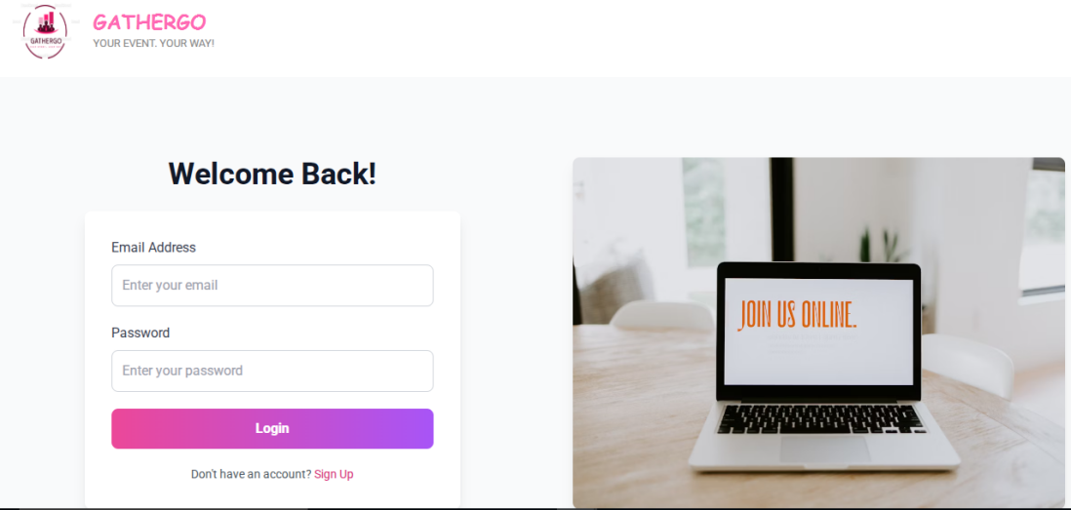

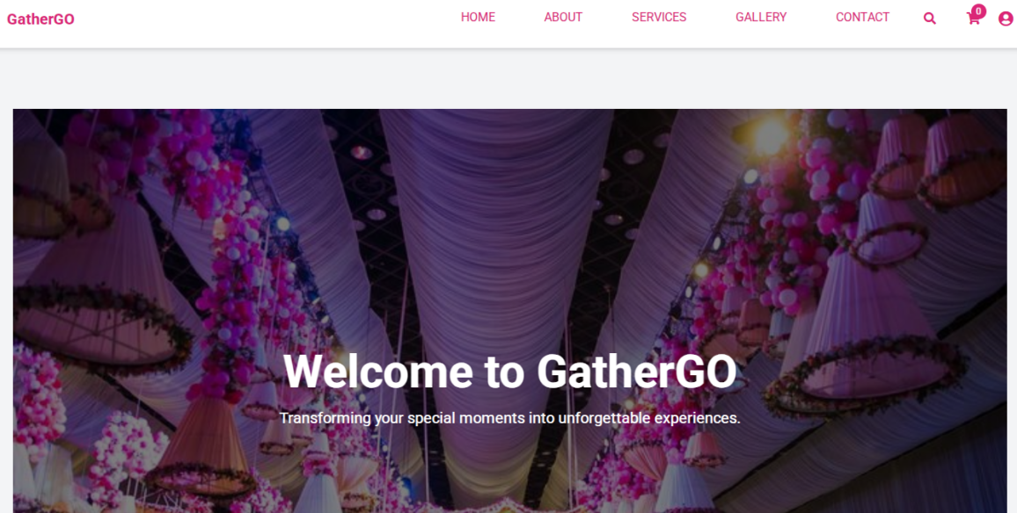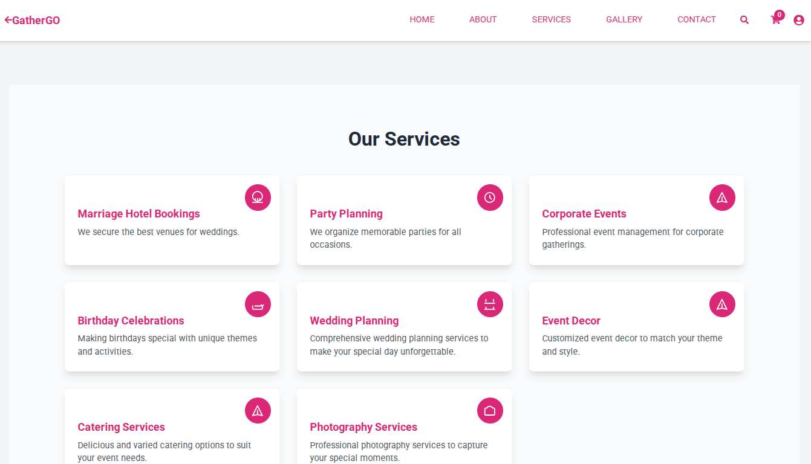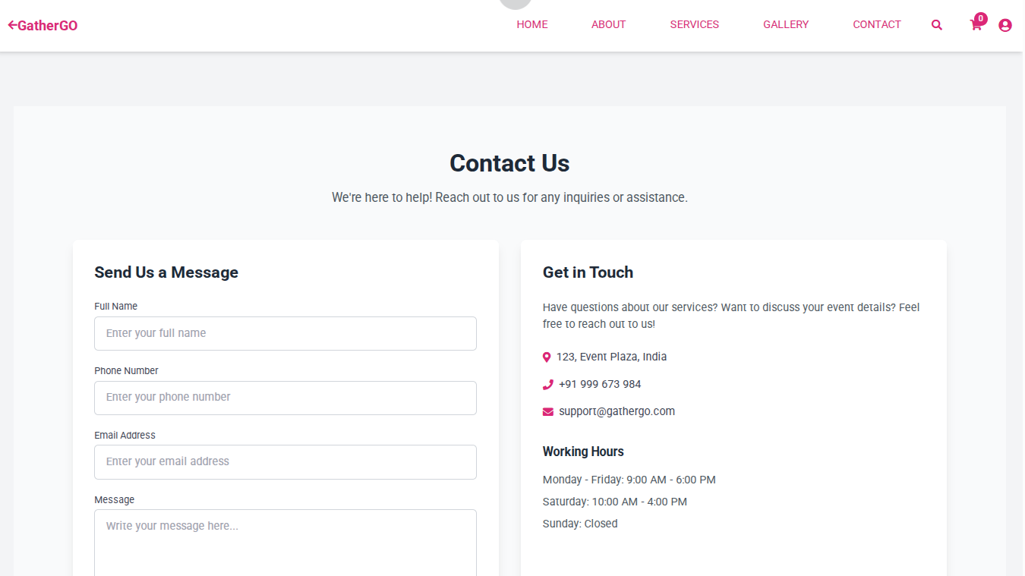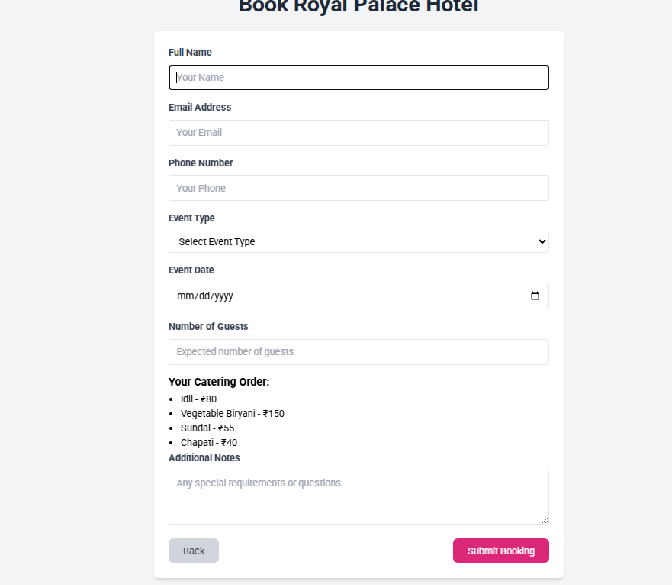

### ****CONCLUSION:****

The Online Event Management System aims to revolutionize event planning by providing a centralized platform that streamlines the management of events, vendors, guests, and payments. By automating and integrating various aspects of event planning, the system reduces human errors, improves coordination, and enhances the overall event experience for organizers and attendees alike.

Key features like real-time tracking, vendor management, and secure online payments are designed to cater to the growing demand for seamless event execution. With scalability and future upgrades in mind, the system offers long-term potential to support various event types and user needs.

In conclusion, this project provides an efficient solution to the challenges faced by event organizers, ensuring a smooth, hassle-free experience for all stakeholders involved.

### ****REFERENCES :****

1. **Book Title**: Web Development and Design Foundations with HTML5  
   Author: Terry Felke-Morris  
   Edition: 9th Edition
2. **Research Paper**: Event Management Systems: A Survey  
   Author(s): James R. Mason et al.
3. **Website**: W3Schools  
   URL: <https://www.w3schools.com/>
4. **Online Resource**: React Documentation  
   URL: https://reactjs.org/docs/getting-started.html  
   Description: Official documentation for React.js, a JavaScript library for building user interfaces.